# Overview

Mobile LIMA is piece of software written in Android Studio, designed to act as a controller that can be used in the LIMA application. The user can use gestures on the mobile that are sent to the LIMA sever and will perform actions on the LIMA application.

# Main Screen

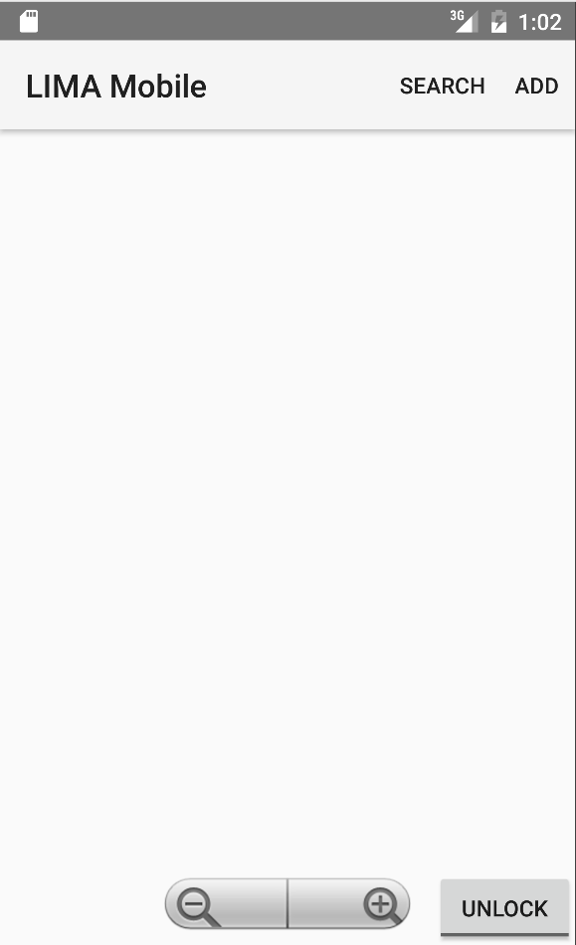This is the screen that will appear when you first open the application. There are several interactions that can be utilised here

### Lock Button

This button is the lock screen button, if the app is “locked” then when you move your finger across the screen you will move the mouse on the LIMA application. By unlocking the app it will allow the user to use swipe gestures to move across the map on the LIMA application. (Note: check the bug section is the mouse is not moving smoothly)

### Zoom in/Zoom out

This component has two buttons the left most is the **zoom out** button and the right is the **zoom in**. This will either zoom in or out on the LIMA maps.



### https://i.gyazo.com/da3b93d017bbdce1c7cd0a065a880c6a.pngSearch

This button will bring up another dialog that will give you three different search options, from here you can search by Name, GPS or National Grid. This will send the relevant information across the server related to the search.



### https://i.gyazo.com/b92d568ff1549da03a59584df7eee894.pngAdd

This button will bring up another dialog that will give a list off placeables that will be placed on the LIMA application in the current mouse position.

# https://i.gyazo.com/b6b0407b04f84d9cd768f986e08bb5c0.png

### https://i.gyazo.com/7cb71fb846170f9b6ea34d290f3c0352.pngNavigation Handler

This button will bring up another dialog that will give a list off placeables that will be placed on the LIMA application in the current mouse position.

### Connect

In this dialog enter an IP you wish to connect to and press connect to connect to the server application if it’s running.

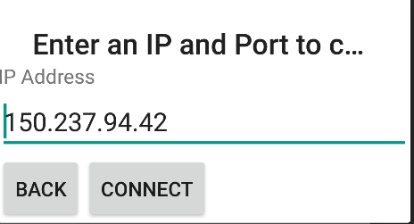

### Mouse Type

This will change the current mouse type being used in the LIMA application. The messages will send across but they do not currently perform any action on the application. To implement this functionality use the same code that should change the mouse type with the number keys in the LIMA application.

### Roads

Here you can change the road type being viewed on the application, you can select between Road, Height and Satellite.

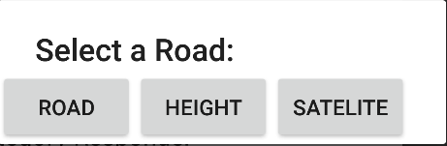

### https://i.gyazo.com/8af4c9638ad3c693aaff93e8fbe09afc.pngWind

Here you can settings on the wind in the LIMA application. You can enter a wind direction but this will not work currently. To change the wind direction you need open the wind panel by pressing ok then clicking the direction you want on the compass.

You can manually enter a wind speed which will be applied, or you can press the + or – buttons to increment or decrement the current wind speed.

### https://i.gyazo.com/600811acfe6a4a75057147a79eefec9f.pngEvent Timer

This is the controls for the event timer. Apply will set the current time you have set on the phones time selector, play and pause will do as expected, the + and – buttons will increase or decrease the speed of the event timer.

### Category Responder

Pressing this will open up the category responders panel on the LIMA application.

### Address Book

When the mobile application connects to the server it receives the addresses currently stored in the applications address book, the address book on the mobile will display the list of addresses stored. When you press the individual address the LIMA application will go to that address.

### Settings

This is the settings menu, you can check what items you want enabled, interact with the height level slider, set a resolution and set the mouse speed as mentioned in the bug section above. Pressing apply will apply the changes.

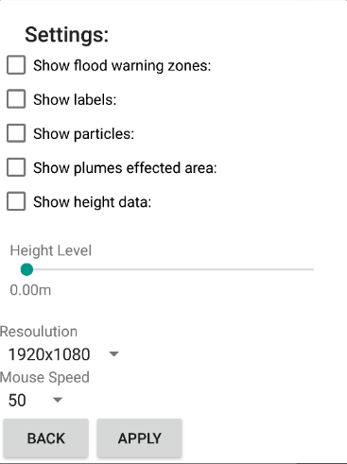

### Bugs

* If the mouse does not move smoothly then go into the settings of the mobile app. There is a mouse speed option, when sending across the messages to move the messages will merge due to the speed its sending I’ve tried several solutions to try and fix this like dynamically settings the length of the byte arrays before sending but it would still have problems. Currently the thread sleeps when sending across mouse movement requests, the mouse speed changes the amount of sleep applied on the thread. You will be able to get a smooth moving mouse by trying the different mouse speeds, it’s different depending on the machine you are connected too.

I’ve been working on a fix for this by using UDP connections for the mouse movement that I’ve only partially implemented, on the server end it listens for UDP connections but it doesn’t actually send across the UDP messages yet.